Predictive Modelling for Early Detection of Health Risks Using Supervised Machine Learning

By
Imtiyaz Mohammed

Project Statement:
In healthcare, it’s very important to identify patients who might be at risk of serious conditions like stroke or heart disease as early as possible. Thanks to the growing availability of patient health data, we can now use machine learning to find patterns and predict which people are more likely to get sick. This project uses supervised learning methods on a healthcare dataset to predict if a person might develop a health problem based on their lifestyle, background, and medical details. The goal is to test and compare two different machine learning models to find out which one gives the best results for early health risk prediction and better medical planning.
Dataset Source:
https://www.kaggle.com/datasets/bharath011/heart-disease-classification-dataset/data
Data Pre-processing:
Handling Missing Data
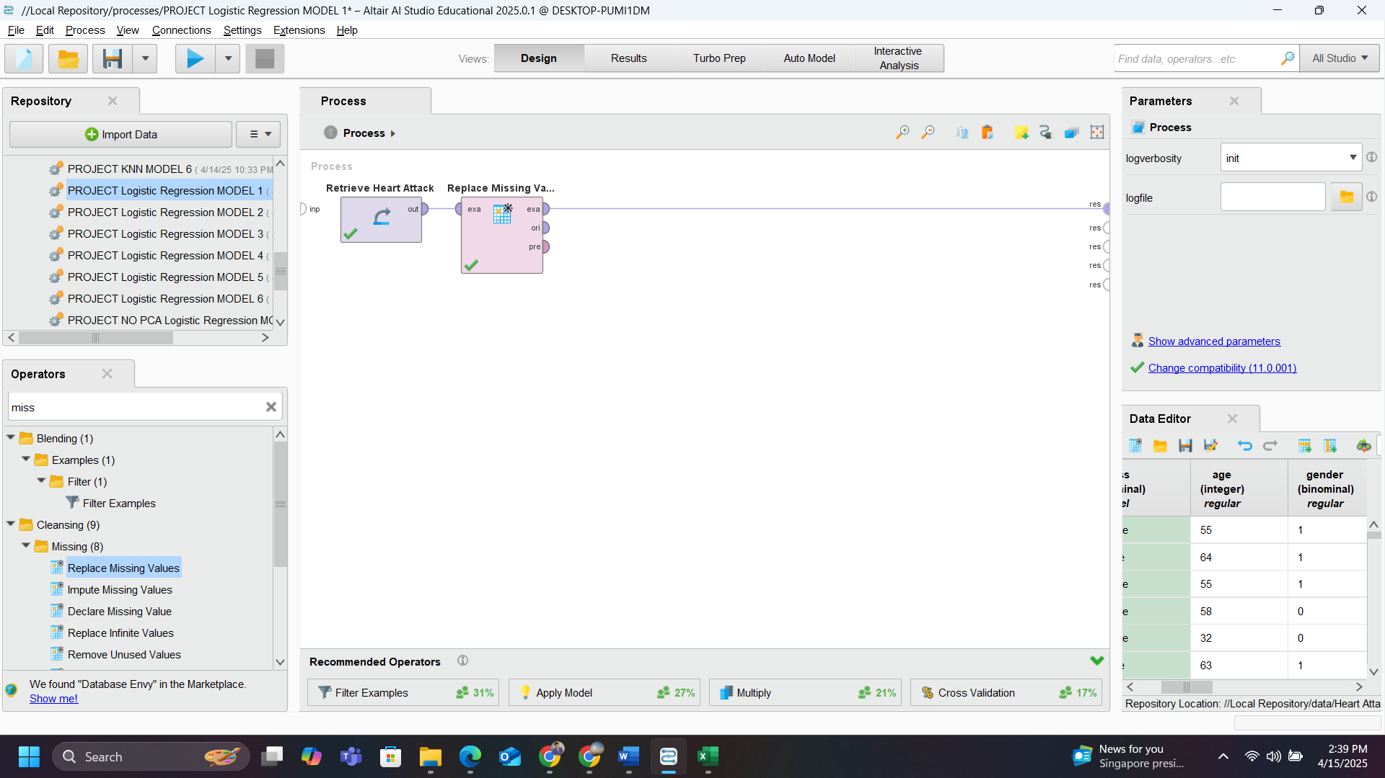
Design for Handling Missing Data

Using the replace missing data operator If there are any missing data will be replaced according to their labels in this case integer and real values will be replaced with Mean and polynomial and binominal will be replaced with mode.
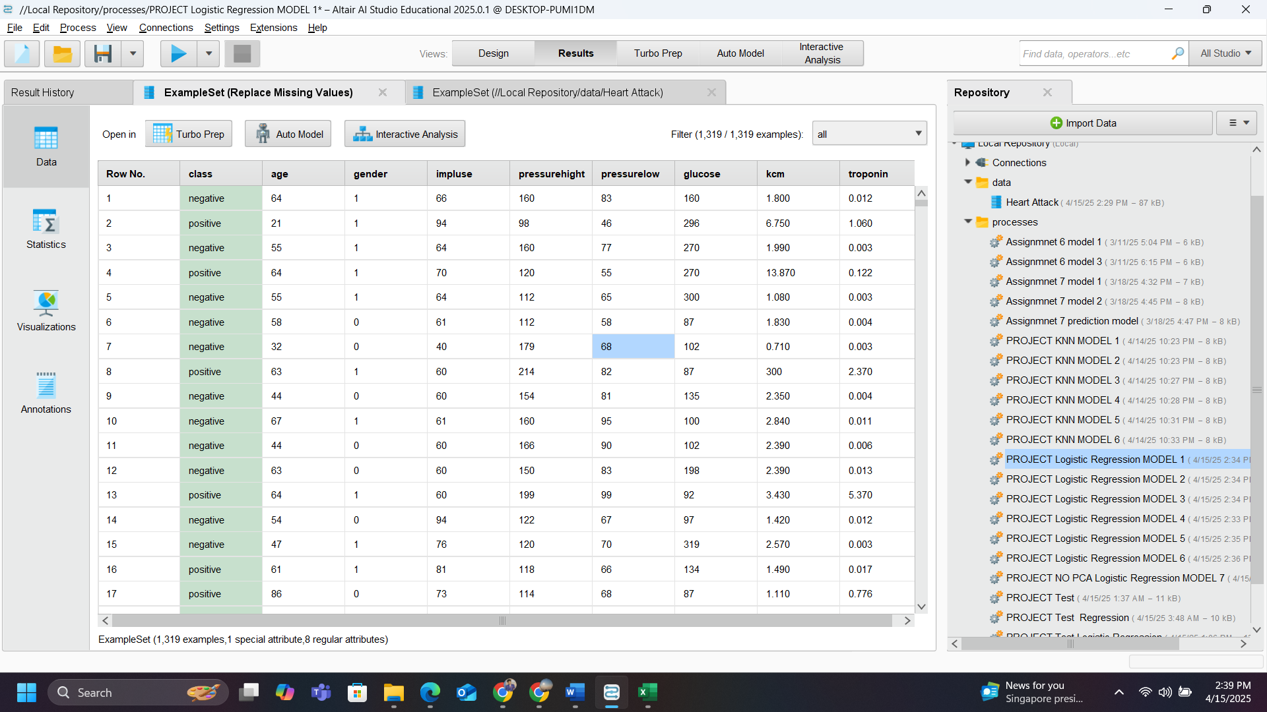
Dataset After Replacing Missing Data
For dummies creation if there are any categorical values in the dataset. Since the dataset is categorical but does not have any non-numerical values so dummies were not considered.

Principal Component Analysis (PCA)
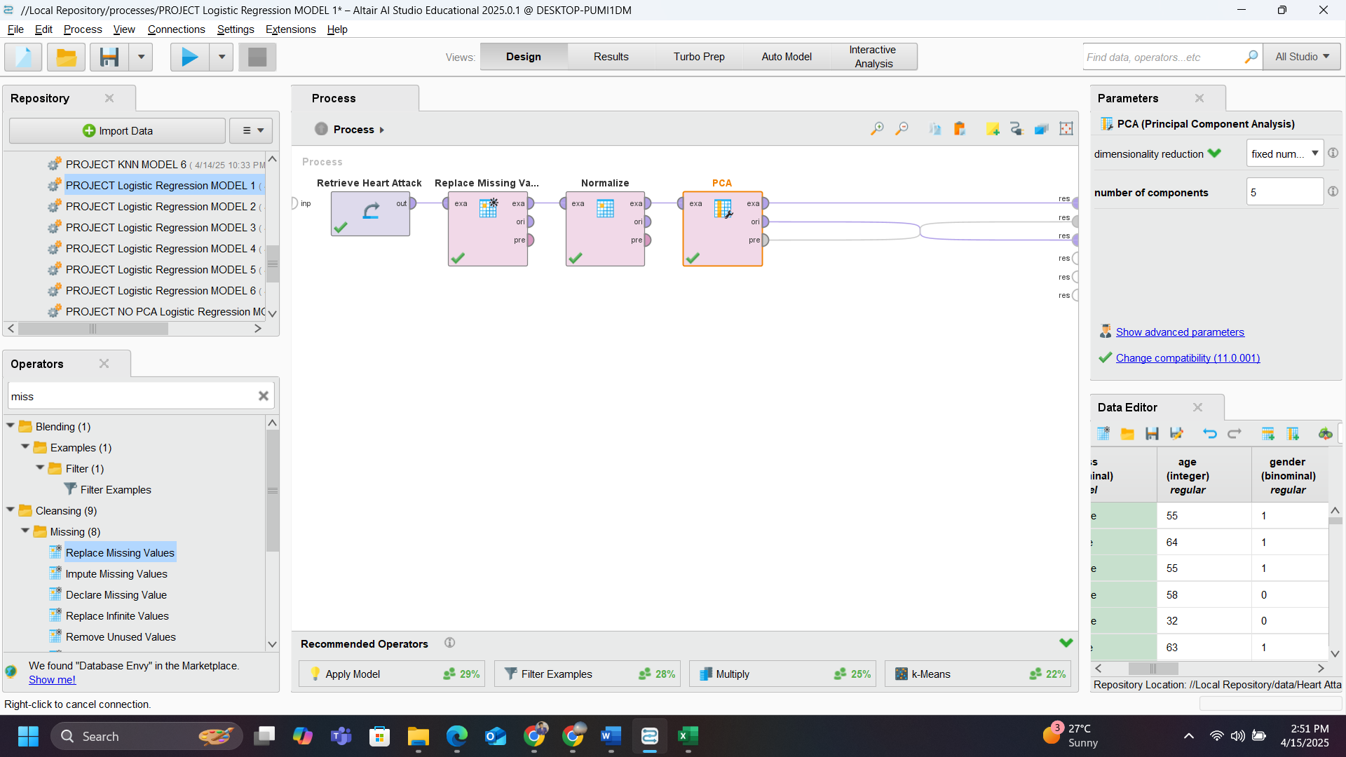
Design of PCA
Here we are considering normalization for PCA to work in comfortable condition to get accurate results
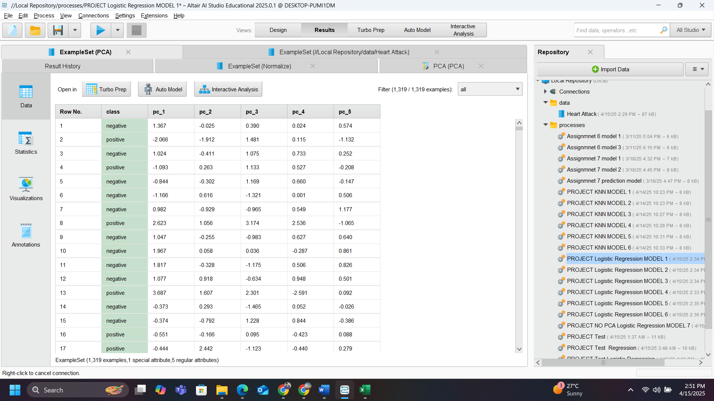
After PCA Top 5
- Low Pressure
- Age
- Gender
- KCM
- Impulse
These are the top 5 PCA, the cumulative variance of these 5 PCA is about 53% which is not good for predicting the new data.
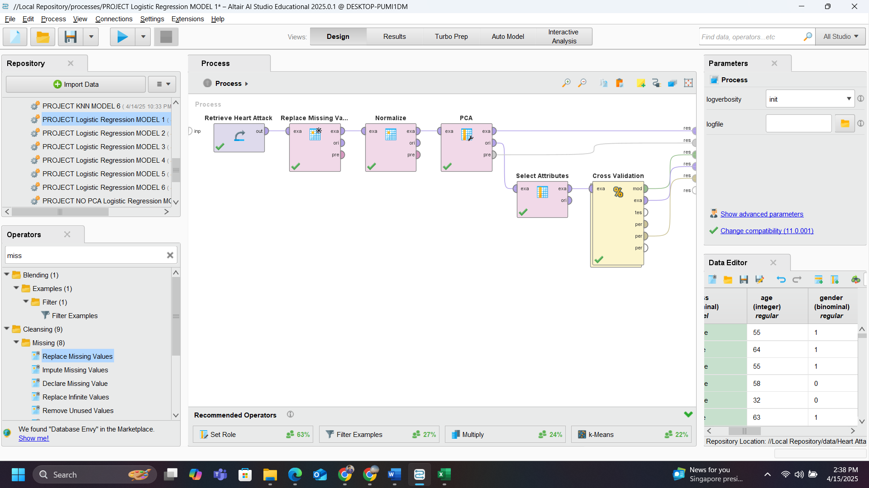
Design of model 1 for training the data with PCA
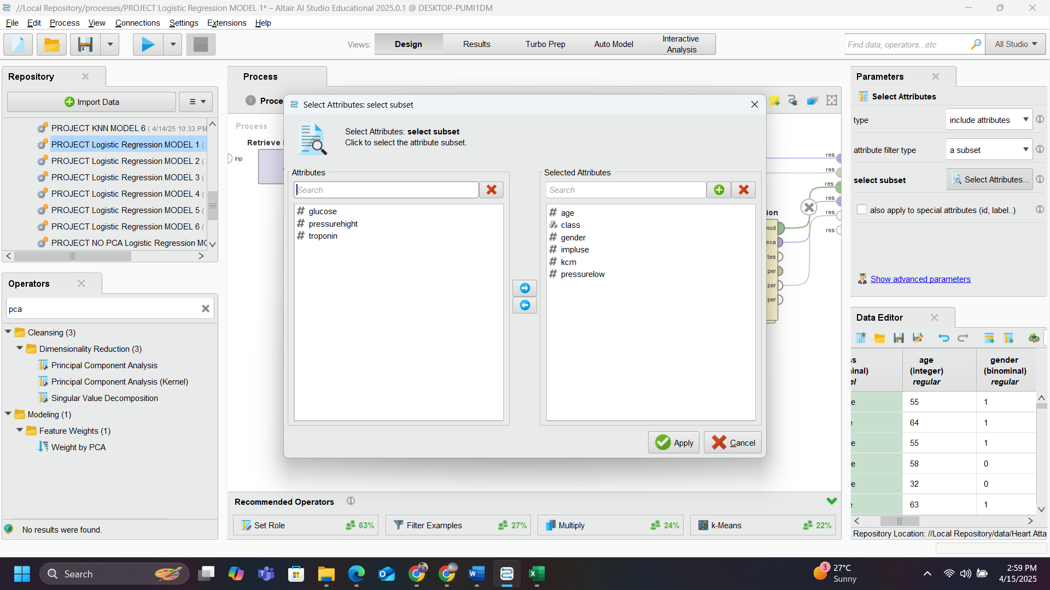
Inside of Select attributes
Here is I have used Select attribute because of PCA top 5 and the Predictor for the Cross validation
To explain the process of the design until now is the
- The input data is passed to missing data handling and moved on to Normalisation operator.
- From Normalisation to PCA where we determine the PCA top 5. Instead of PCA data we are using original data from before for select attribute operator and selecting the top5 attributes along with predictor
- This selected data is passed to the cross-validation operator for further use.
The dataset is to determine the class hence this data set comes in Classification
The two Data mining techniques that I Choose is
- Logistic Regression and
- Decision Tree
Reason for choosing these are I have tested all other techniques including Naïve bayes, K-NN, and Neural Network and gave the accuracy of 60 to 70% which was not ideal for prediction.

Logistic Regression
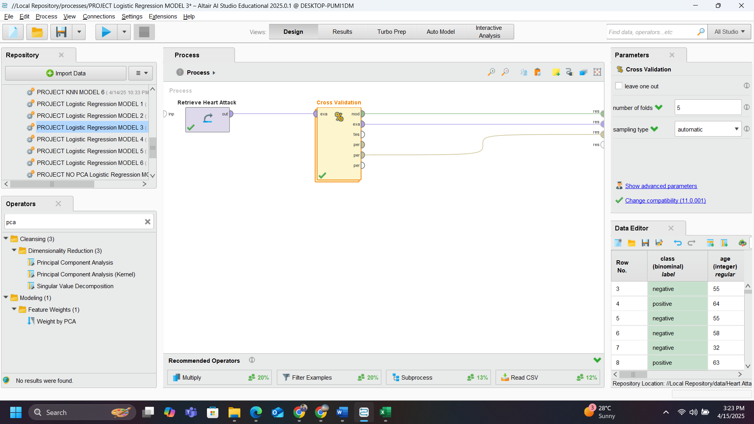
Design for the Logistic Regression Model
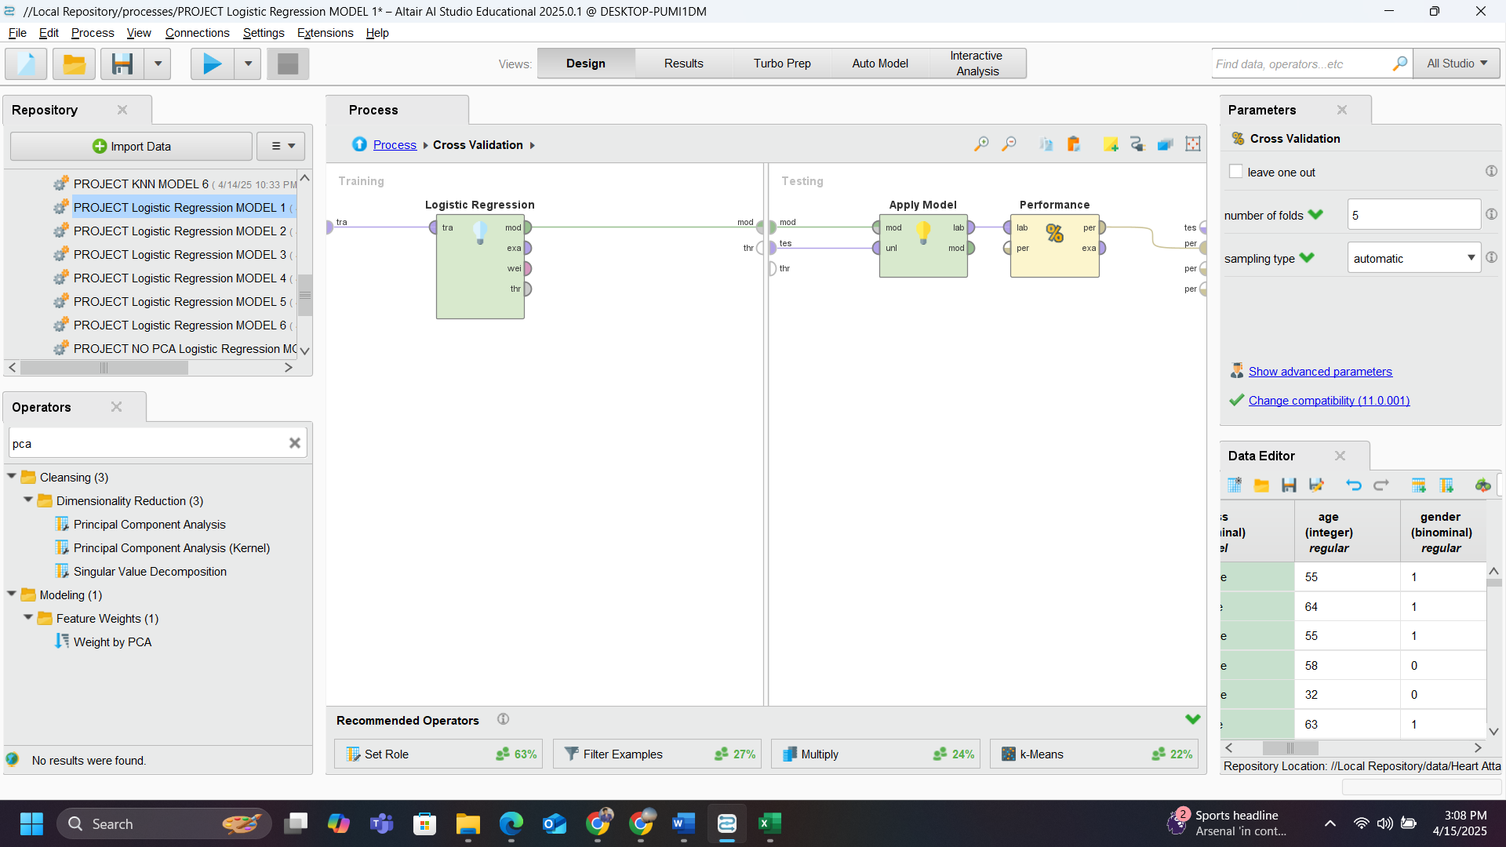
This is the inside of Cross Validation operator where logistic Regression is my first data mining algorithm is being used. Logistic regression is connected to apply model and performance model.
After few Trial-and-error method I was able to determine the for 7 folds is the best model for predicting new data.
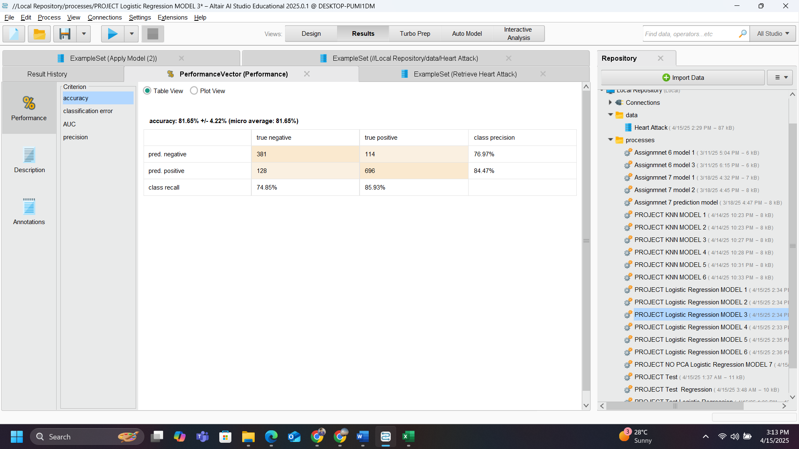
Performance result of dataset at 5 folds

Model Table for Logistic Regression
At 7 folds and no PCA gave me the highest accuracy about 82.50% and increasing or decreasing the number of folds is affecting negatively.
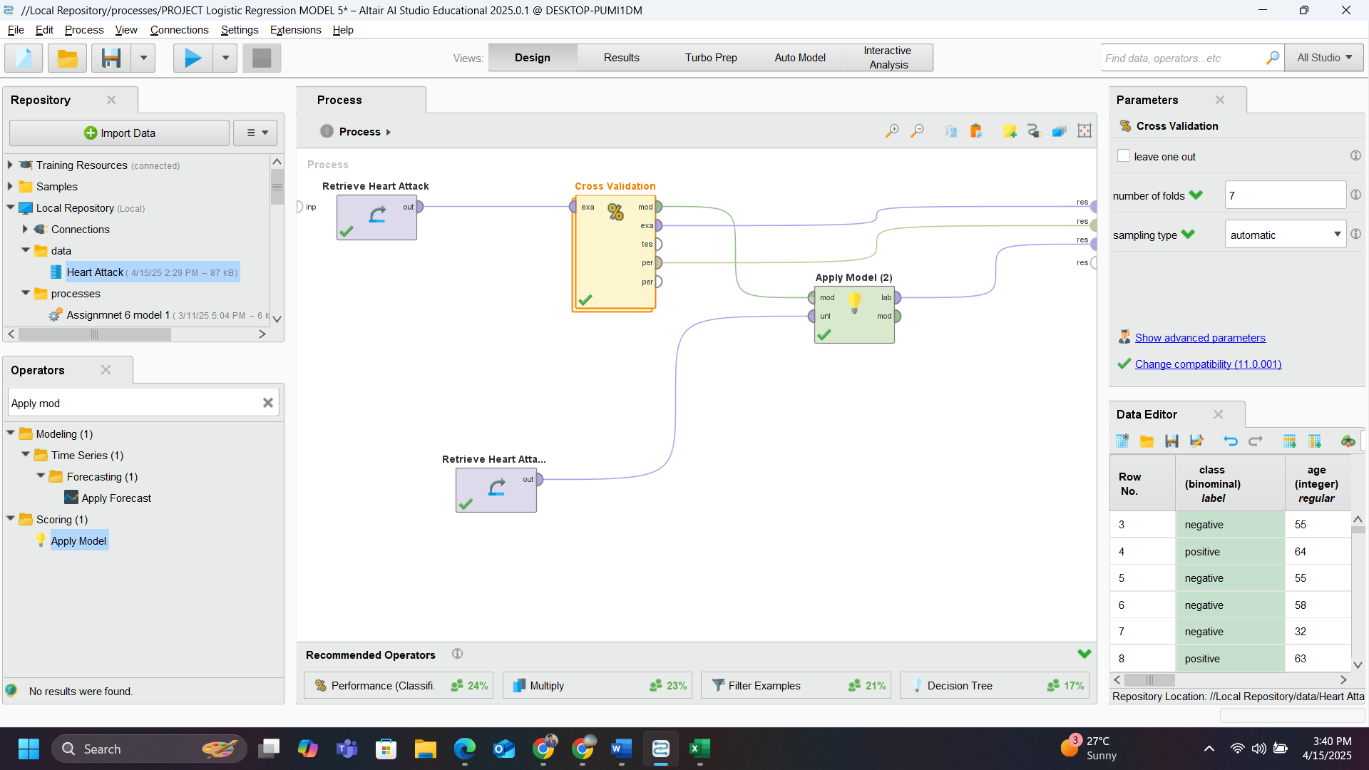
Design for using the best model for Prediction
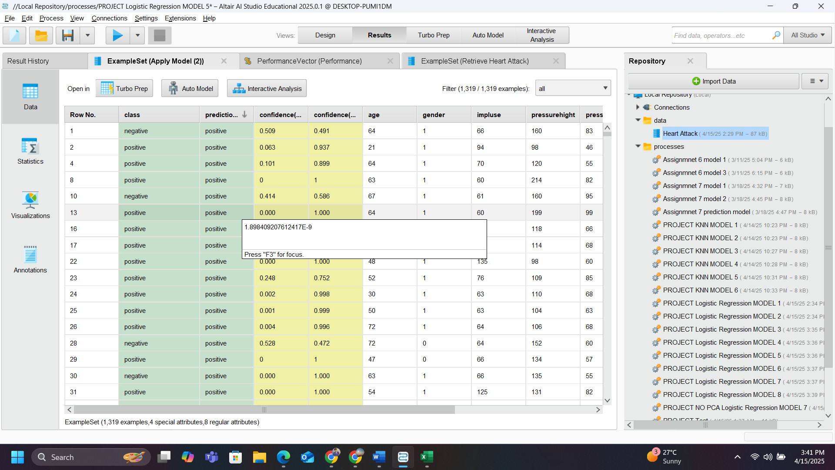
First few predictions of data being predicted as positive.
The red box is the actual value and the blue box is the prediction which needs to get. As the Accuracy is only about 82.50% so there are some wrong predictions. There were 236 wrong predictions in total.

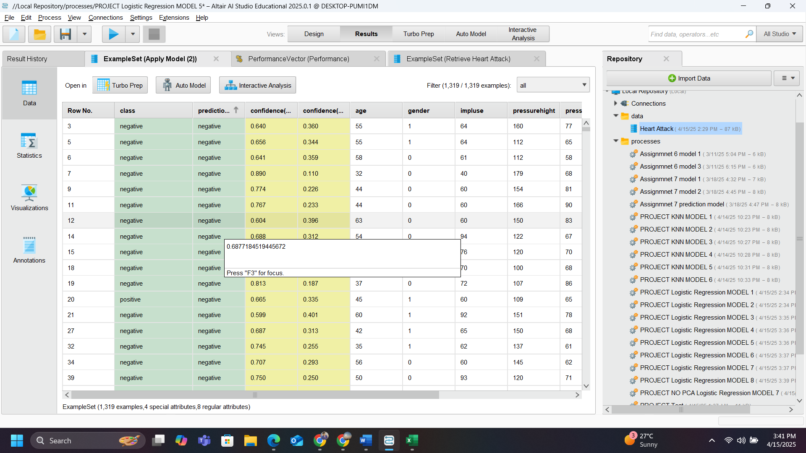
First few predictions of data being predicted as positive.

Decision Tree
Decision Tree Algorithm can be used for both classification and regression For PCA and since we already did the PCA and selected our top 5,
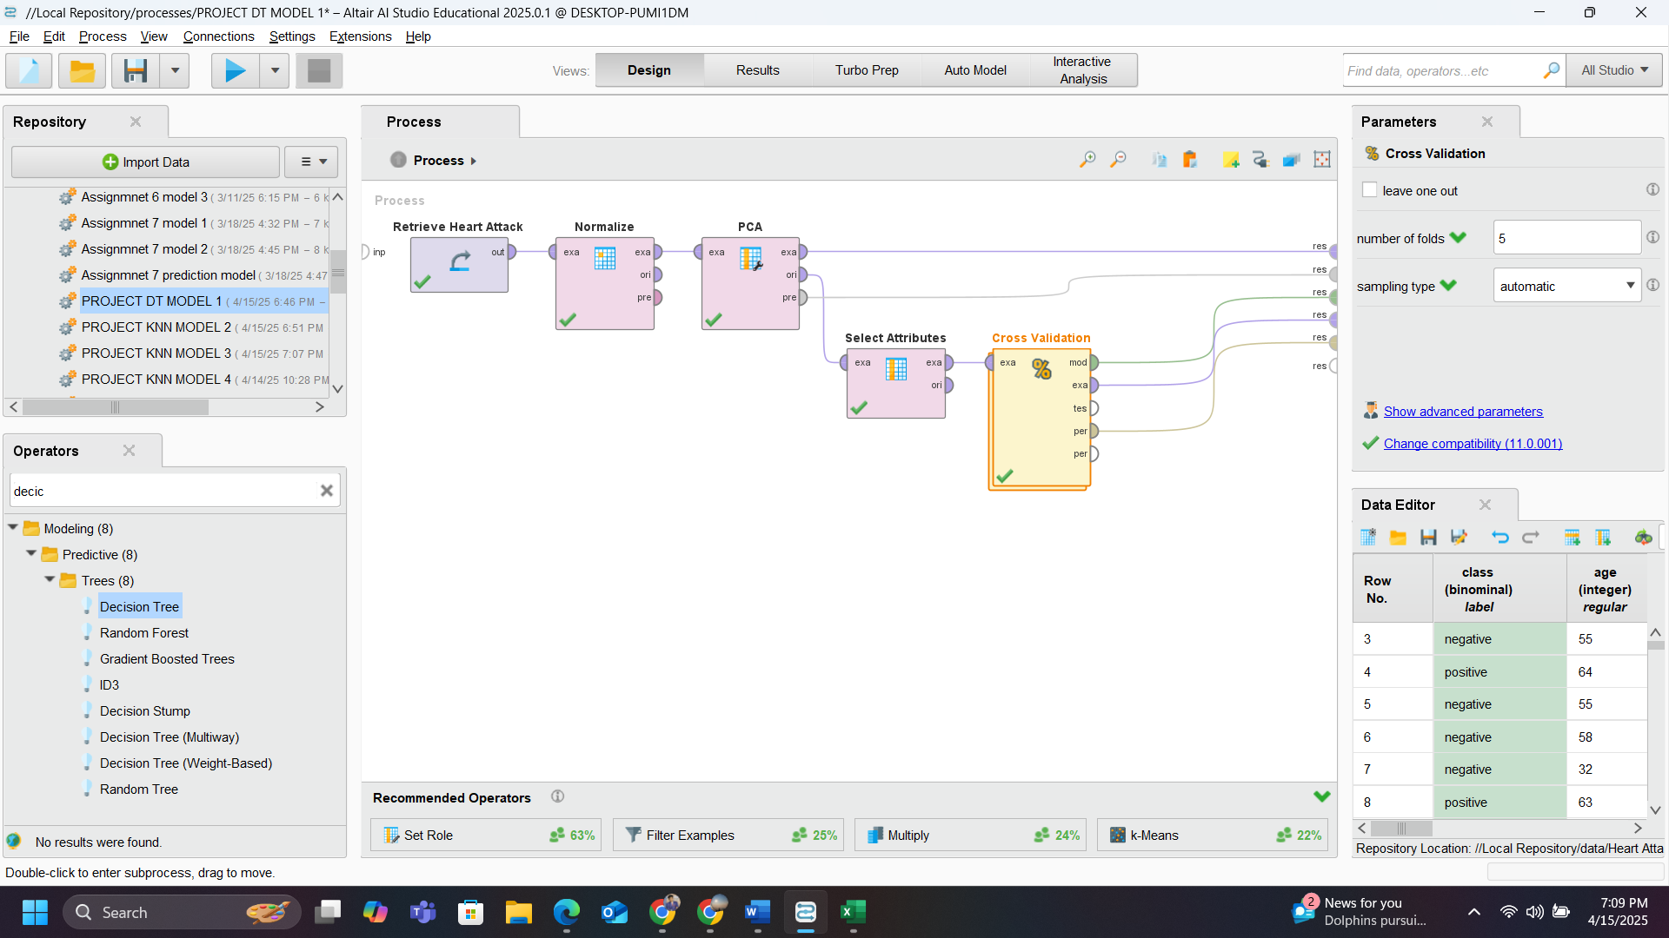
Design for model 1 for Training data with PCA top 5.
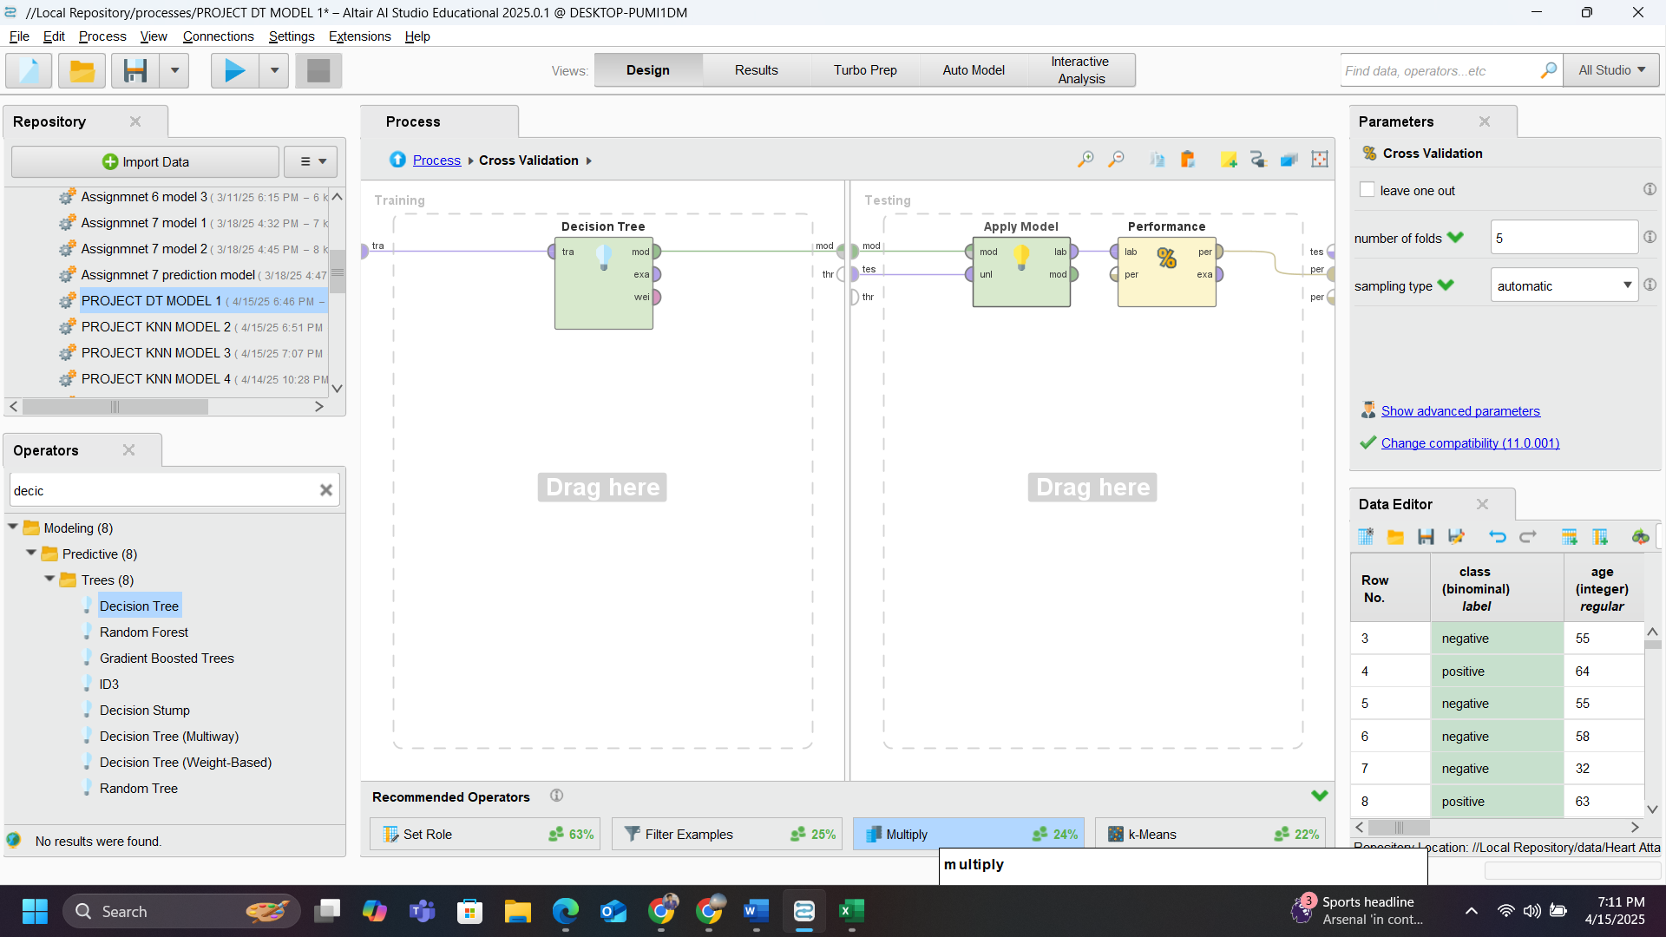
Inside of cross validation operator
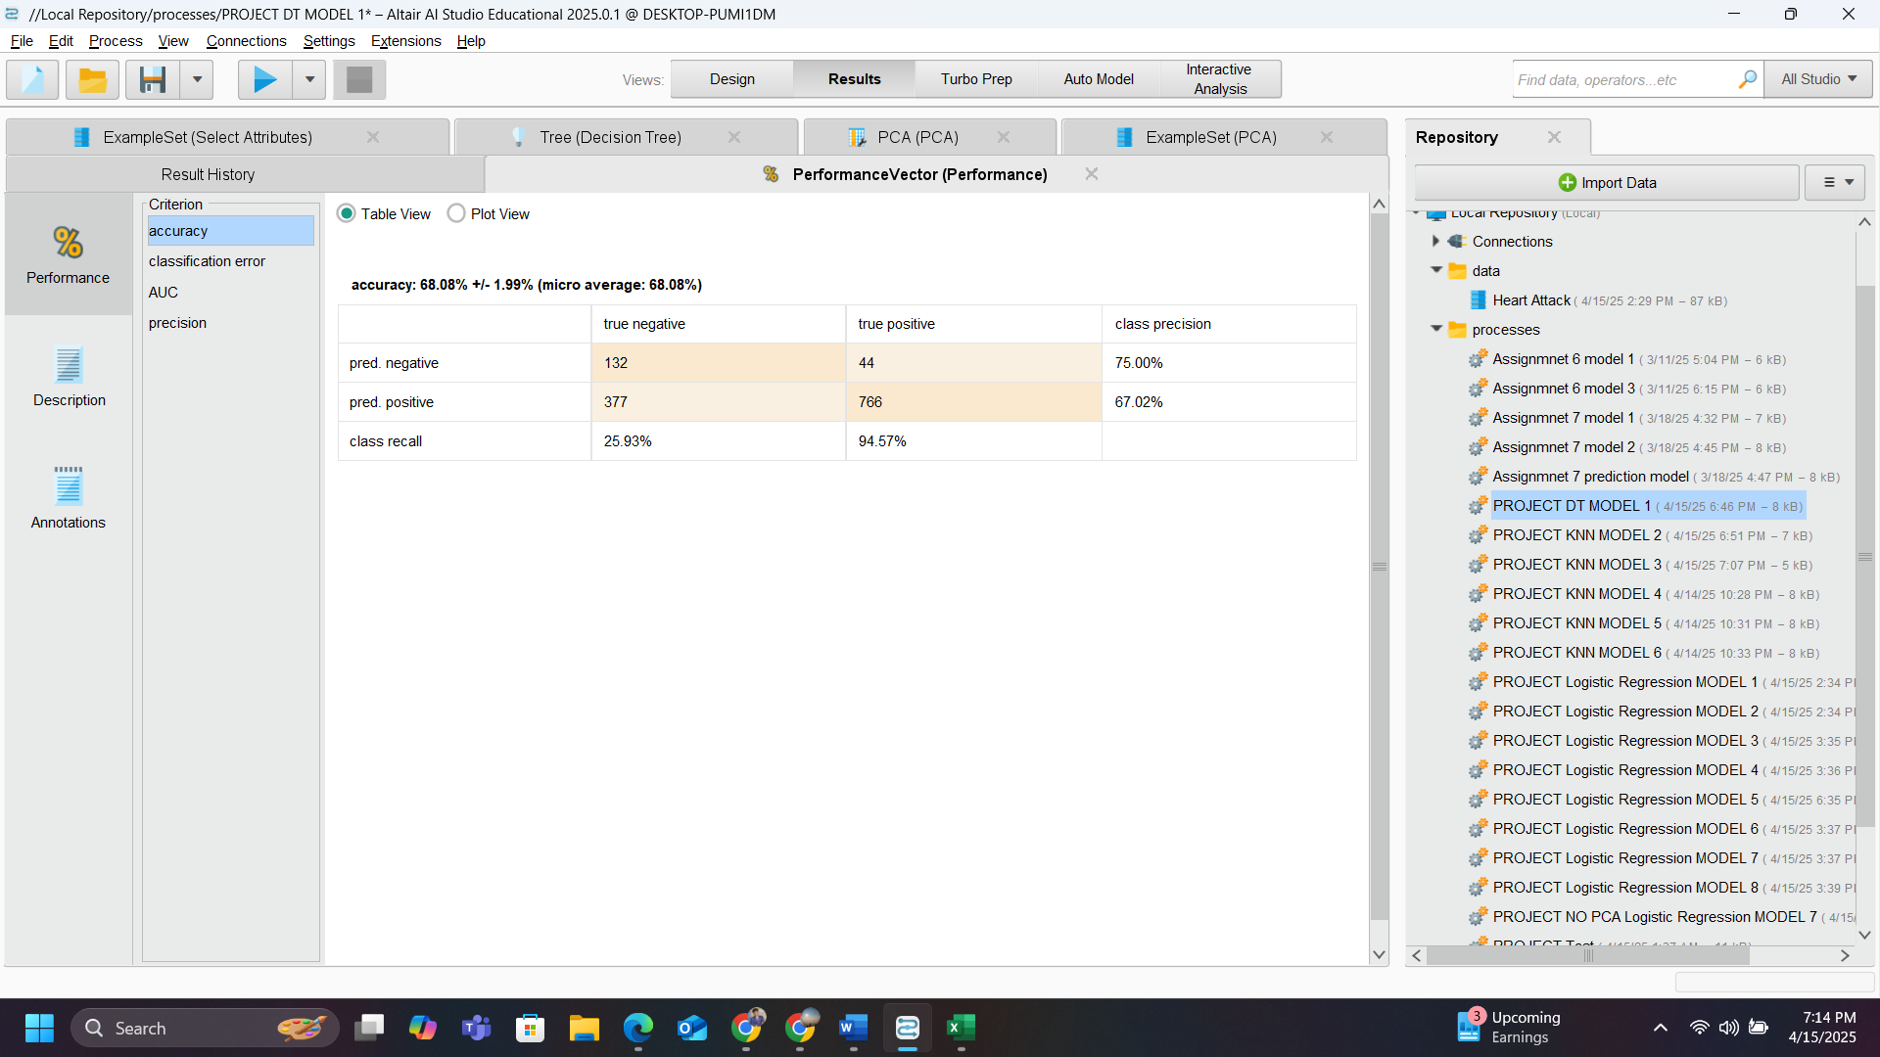
Performance vector
After training the data set using the PCA the accuracy is about 68.08% and the error of 31.92%, which is not ideal for predicting.
Decision tree has different criterion namely Information gain, Gain ratio and accuracy
Information gains help Measures how much a feature helps reduce uncertainty (entropy) about the target variable. Gain Ratio is a normalized version of Information Gain. And The percentage of correct predictions made by the model out of all predictions.

Model Table
I tested Gain Ratio and Information Gain and Accuracy as splitting criteria for the Decision Tree. Gain Ratio is generally preferred when working with categorical attributes that have many distinct values, in this dataset, Information Gain and accuracy a slightly the same accuracy and almost every time gain ratio was performing better (98.86% vs. 98.48% vs 98.48%). Therefore, we selected Gain Ratio as the splitting criterion for our final decision tree model.
After considering both 6-fold and 9-fold cross-validation. As both yielded the same accuracy (98.86%), we selected 6-fold cross-validation for its computational efficiency and adequate sample distribution across folds.

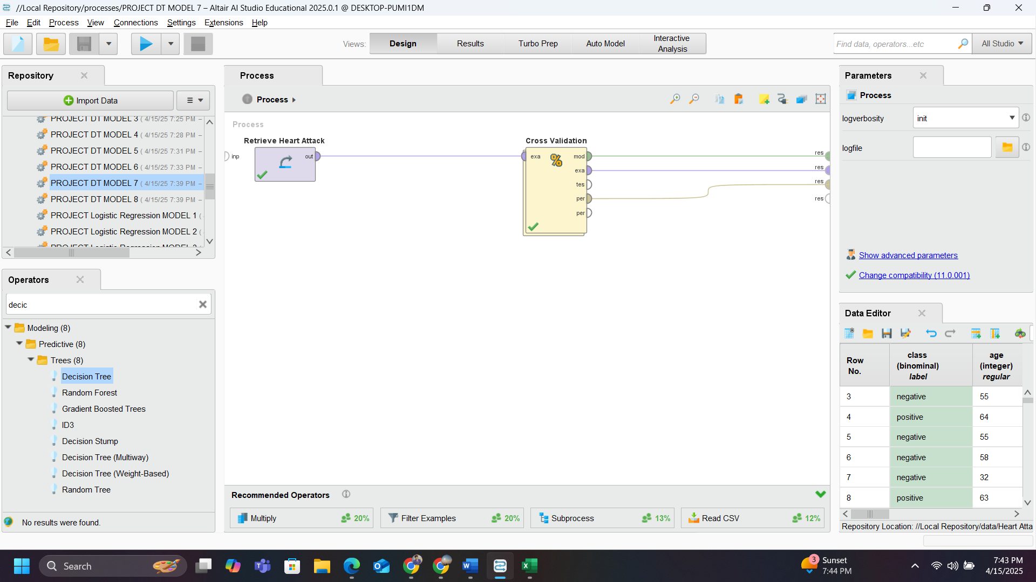
Design of Best model
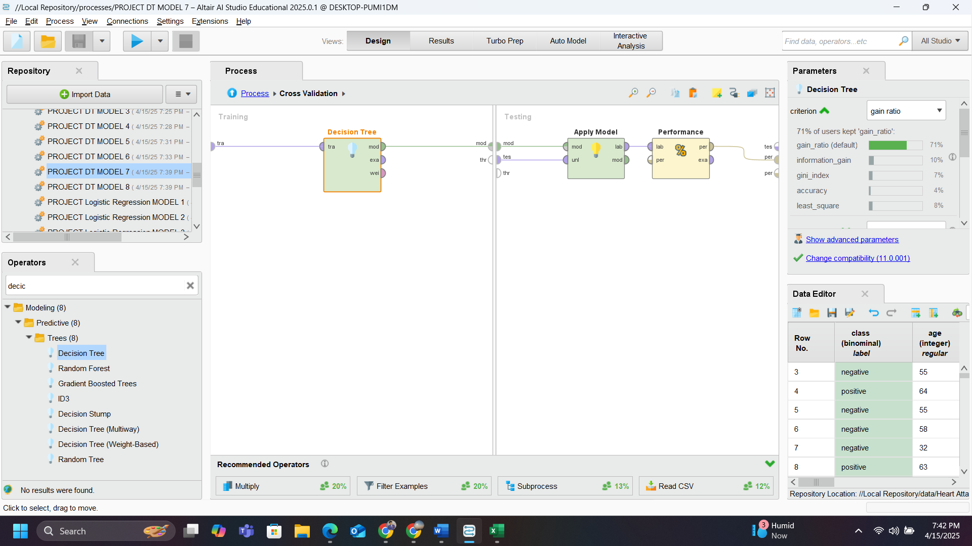
Inside of cross validation for best model

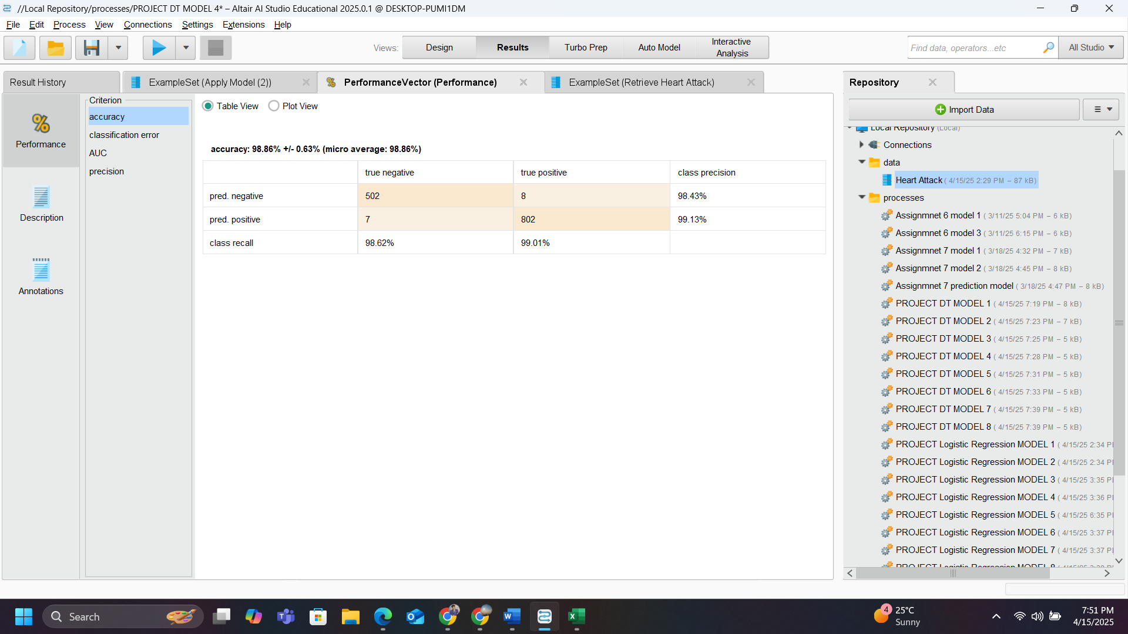
Performance Vector for Best model
With an Accuracy of 98% in which 8 are predicted as false negative and 7 as false positive. In total 15 errors were recorded.

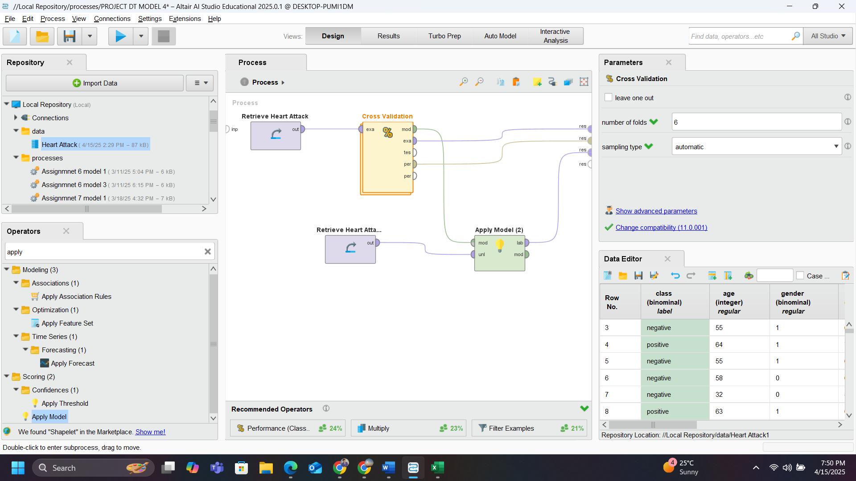
Design of best model for prediction

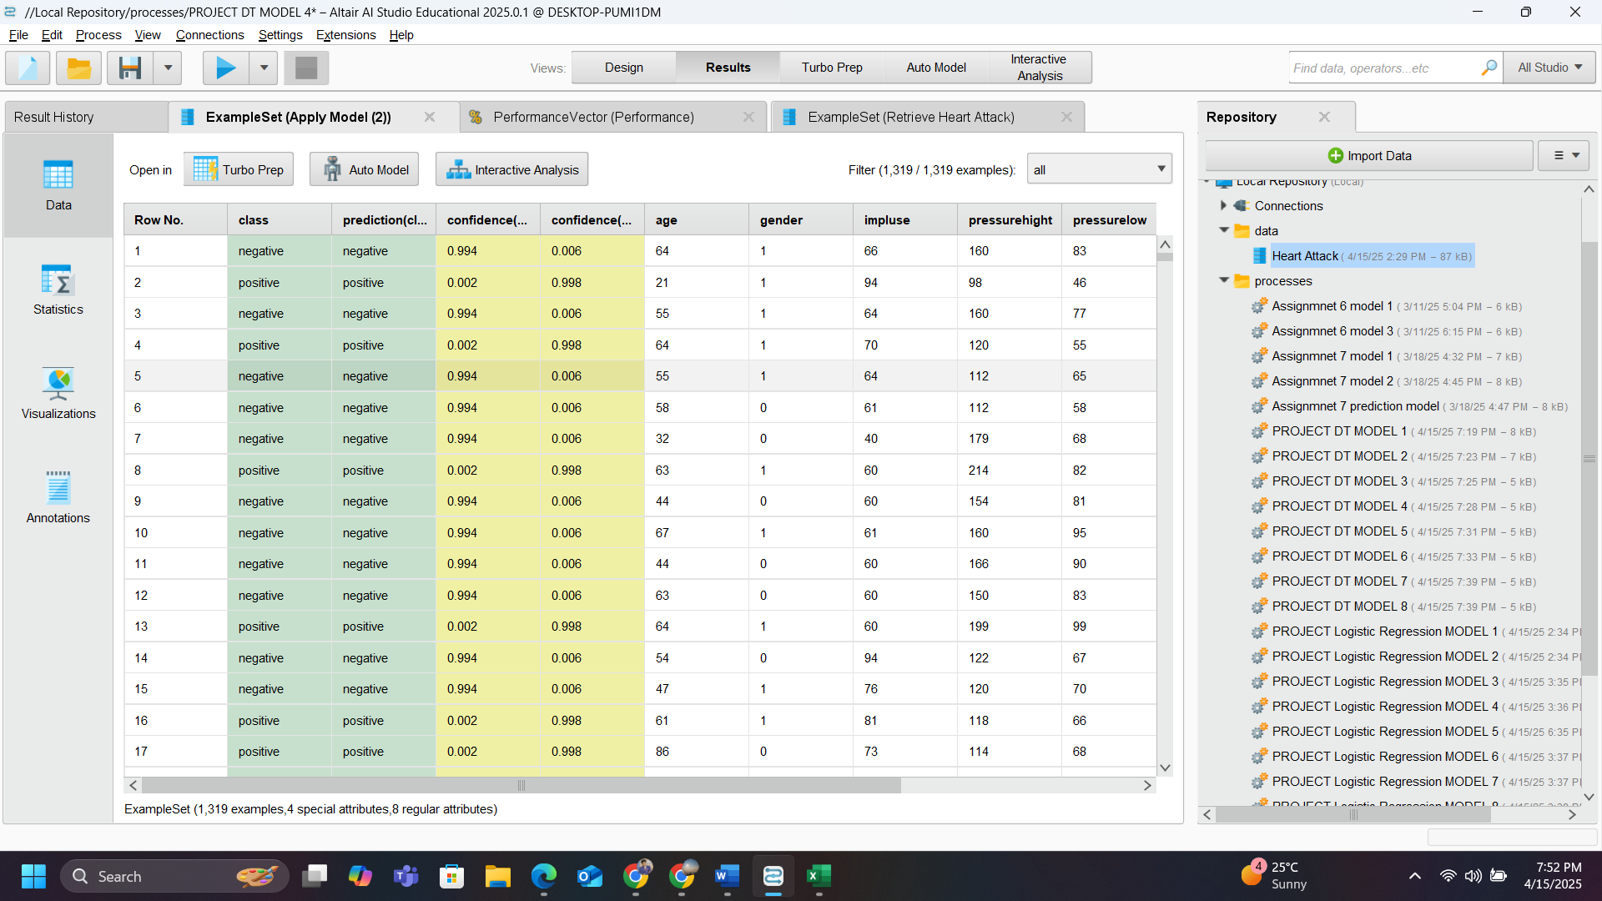
Prediction of the data set using Best Model
Conclusion:
Both Logistic Regression and Decision tree were the top classification Algorithms for prediction, after getting the results from both algorithms we can say that Decision tree performed amazingly when compared to Logistic Regression and all other algorithms, with this experiment I can conclude that every dataset has their own best algorithm that we need to find as a Data mining Analysts, in this case it was Decision tree.

